Water Resources Systems Engineering Assignment #2
2022-32658 이주형
1. A.
(a) $Present Value= \frac{Future Value}{{(1+r)}^{n}}$
$$V_{0,A}^{P}=-\$2,533,000+\frac{\$1,000,000}{{1.1}^{5}}+\frac{\$4,000,000}{{1.1}^{10}}=-\$369,905.52$$
$$V_{0,B}^{P}=-\$4,000,000+\frac{\$2,000,000}{{1.1}^{5}}+\frac{\$3,000,000}{{1.1}^{10}}+\frac{\$2,000,000}{{1.1}^{15}}=-\$1,122,743.38$$

(b) $Average annual net benefit= V_{0}^{P}\left[r{(1+r)}^{T_{p}}\right]/\left[{(1+r)}^{T_{p}}-1\right]$
$$V_{A}^{P}=-\$369,905.52*\frac{\left[0.1*{1.1}^{10}\right]}{\left[{1.1}^{10}-1\right]}=-\$60,200.42$$
$$V_{B}^{P}=-\$1,122,743.38*\frac{\left[0.1*{1.1}^{15}\right]}{\left[{1.1}^{15}-1\right]}=-\$147,611.31$$

(c) $$V_{0,A}^{P}=-\$2,533,000+\frac{\$1,000,000}{{1.05}^{5}}+\frac{\$4,000,000}{{1.05}^{10}}=\$706,179.18$$
$$V_{0,B}^{P}=-\$4,000,000+\frac{\$2,000,000}{{1.05}^{5}}+\frac{\$3,000,000}{{1.05}^{10}}+\frac{\$2,000,000}{{1.05}^{15}}=\$370,826.29$$

(d)
$$V_{0,A}^{P}=-\$2,533,000+\frac{\$1,000,000}{{1.1}^{5}}+\frac{\$4,000,000}{{1.1}^{10}}-\frac{\$2,533,000}{{1.1}^{10}}+\frac{\$1,000,000}{{1.1}^{15}}+\frac{\$4,000,000}{{1.1}^{20}}-\frac{\$2,533,000}{{1.1}^{20}}+\frac{\$1,000,000}{{1.1}^{25}}+\frac{\$4,000,000}{{1.1}^{30}}=-\$567,504.21$$
$$V_{A}^{P}=-\$567,504.21*\frac{\left[0.1*{1.1}^{30}\right]}{\left[{1.1}^{30}-1\right]}=-\$60,200.42$$
$$V_{0,B}^{P}=-\$4,000,000+\frac{\$2,000,000}{{1.1}^{5}}+\frac{\$3,000,000}{{1.1}^{10}}+\frac{\$2,000,000}{{1.1}^{15}}-\frac{\$4,000,000}{{1.1}^{15}}+\frac{\$2,000,000}{{1.1}^{20}}+\frac{\$3,000,000}{{1.1}^{25}}+\frac{\$2,000,000}{{1.1}^{30}}=-\$1,391,519.23$$
$$V_{B}^{P}=-\$1,391,519.23*\frac{\left[0.1*{1.1}^{30}\right]}{\left[{1.1}^{30}-1\right]}=-\$147,611.31$$
B.
$$R\left(x_{1}\right)=12x_{1}-x_{1}^{2}$$
$$R\left(x_{2}\right)=8x_{2}-x_{2}^{2}$$
$$R\left(x_{3}\right)=18x_{3}-{3x}_{3}^{2}$$
$$x_{1}+x_{2}+x_{3}≤10$$
$$L=\left(12x_{1}-x_{1}^{2}\right)+\left(8x_{2}-x_{2}^{2}\right)+\left(18x_{3}-{3x}_{3}^{2}\right)-λ(x_{1}+x_{2}+x_{3}-10)$$
$$\frac{∂L}{∂x_{1}}=12-2x_{1}-λ=0$$
$$\frac{∂L}{∂x_{2}}=8-2x_{2}-λ=0$$
$$\frac{∂L}{∂x_{3}}=18-6x_{3}-λ=0$$
$$\frac{∂L}{∂λ}=10-x_{1}-x_{2}-x_{3}=0$$

$$x_{1}=10-x_{2}-x_{3}$$
$$12-2x_{1}-λ=12-2\left(10-x_{2}-x_{3}\right)-λ=2x_{2}+2x_{3}-λ-8=0$$

$$2x_{2}=8-λ$$
$$2x_{2}+2x_{3}-λ-8=8-λ+2x_{3}-λ-8=0$$
$$x_{3}=λ$$
$$18-6x_{3}-λ=18-6x_{3}-x_{3}=0$$
$$x_{3}=λ=\frac{18}{7}$$

$$2x_{2}=-2x_{3}+λ+8=-x_{3}+8=-\frac{18}{7}+\frac{56}{7}=\frac{38}{7}$$
$$x_{2}=\frac{19}{7}$$

$$x_{1}=10-x_{2}-x_{3}=10-\frac{19}{7}-\frac{18}{7}=\frac{33}{7}$$

C.
Optimal release plan
 | Release 1 | Release 2 | Release 3
0 | 10 | 30 | 10
10 | 10, 20 | 30 | 10
20 | 20 | 40 | 20
30 | 30 | - | 30

I think is easy to solve with final storage volumes as the decision variables because it is possible to find following values with coordinates.

D.

2.
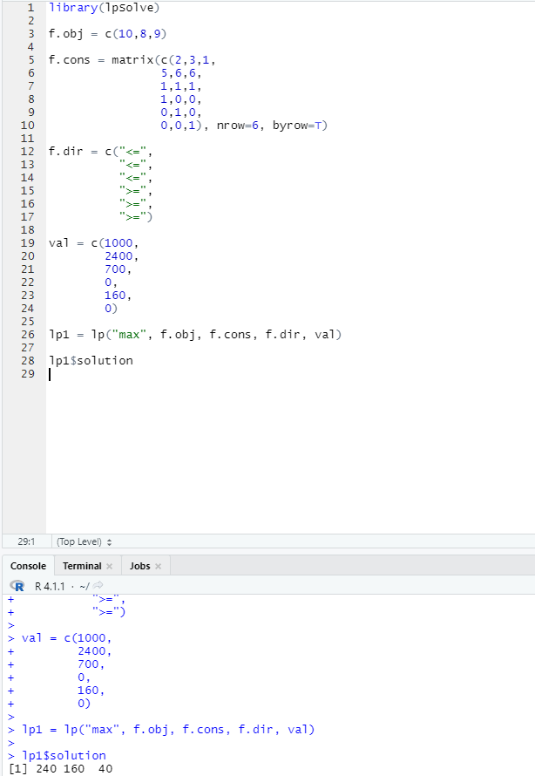

3.
A. Benefit function
One unit of release = $2000
Two units of release = $2000 + $1500 = $3500
Three units of release = $2000 + $1500 + $1000 = $4500
Four units of release = $2000 + $1500 + $1000 + $500 = $5000
Five units of release = $2000 + $1500 + $1000 + $500 - $1500 = $3500
Six units of release = $2000 + $1500 + $1000 + $500 - $4000 = $1000

B. Governing equation
Let $S_{n}$ and ${FS}_{n}$ as initial storage and final storage of season $n$, respectively. Then the governing equation of this problem can be written as
$${FS}_{n}=Q_{n}+S_{n}-R_{n}$$
where $Q_{n}$ and $R_{n}$ are the inflow and release of season $n$, respectively.
Moreover, the final storage of $n$ season is the initial storage of $n+1$ season. It can be written as
$${FS}_{n}=S_{n+1}$$

C. Backward recursive equation
$$f_{n}\left(S_{n}\right)=Max\left[r_{n}\left(S_{n},R_{n}\right)\right] for n=4$$
$$f_{n}\left(S_{n}\right)=Max\left[r_{n}\left(S_{n},R_{n}\right)+f_{n+1}(S_{n+1})\right] for n=1, 2, and 3$$

D. Optimal release plan
Storage | Release 1 | Release 2 | Release 3 | Release 4
0 | 1 | 1, 2 | 1 | 1, 2
1 | 1, 2 | 1, 2 | 1, 2 | 1, 2
2 | 1, 2 | 1, 2 | 1, 2 | 1, 2
3 | 1, 2 | 1, 2 | 1, 2 | 1, 2
4 | 1, 2 | 2 | 1, 2 | 2

Storage | Final storage 1 | Final storage 2 | Final storage 3 | Final storage 4
0 | 0 | 0, 1 | 0 | 0, 1
1 | 0, 1 | 1, 2 | 0, 1 | 1, 2
2 | 1, 2 | 2, 3 | 1, 2 | 2, 3
3 | 2, 3 | 3, 4 | 2, 3 | 3, 4
4 | 3, 4 | 4 | 3, 4 | 4

Code:
library(daewr)

#Storage
s = c(0, 1, 2, 3, 4)

#Release
release.1 = matrix(c(1,0,NA,NA,NA,
2,1,0,NA,NA,
3,2,1,0,NA,
4,3,2,1,0,
5,4,3,2,1), nrow=5, byrow=T)

release.2 = matrix(c(2,1,0,NA,NA,
3,2,1,0,NA,
4,3,2,1,0,
5,4,3,2,1,
6,5,4,3,2), nrow=5, byrow=T)

release.3 = matrix(c(1,0,NA,NA,NA,
2,1,0,NA,NA,
3,2,1,0,NA,
4,3,2,1,0,
5,4,3,2,1), nrow=5, byrow=T)

release.4 = matrix(c(2,1,0,NA,NA,
3,2,1,0,NA,
4,3,2,1,0,
5,4,3,2,1,
6,5,4,3,2), nrow=5, byrow=T)

release = list(release.1, release.2, release.3, release.4)

#ft
benefit.func = c(0,2000,3500,4500,5000,3500,1000)
ft = list()

for (i in 1:4){
#i=1
release.dat = release[[i]]
ft.dat = array(NA, c(5,5))

for (j in 1:5){
#j=1

for (k in 1:5){
#k=1

r = release.dat[j,k]

bene = benefit.func[(r+1)]

ft.dat[j,k] = bene

}

}
ft[[i]] = ft.dat
}

#Backward recursive process
back.ft =list(ft[[4]], ft[[3]], ft[[2]], ft[[1]])
back.release = list(release.4, release.3, release.2, release.1)
ft.result = list(c(),c(),c(),c())

#First step (T=4)
ft.model = back.ft[[1]]
back.r = back.release[[1]]
ll = length(ft.result[[1]])
ft.l = list()
release.l = list()
storage.l = list()
for(k in 1:5){
#k=4
if (is.na(ft.model[k,1]) & is.na(ft.model[k,2]) & is.na(ft.model[k,3]) & is.na(ft.model[k,4])){
next
}
s0 = max(ft.model[k,],na.rm=T)
s0.loc = which(ft.model[k,]==s0)
ss = s[s0.loc]
r = back.r[k,s0.loc]

ft.l[[k]] = s0
release.l[[k]] = c(r)
storage.l[[k]] = c(ss)

}

ft.r = data.frame(cbind(ft.l), cbind(release.l), cbind(storage.l))

ft.result[[1]][[1]] = ft.r

#Backward recursive algorithm
for (i in 2:100){
#i=2
j = mod(i,4)
bb = mod((i-1),4)

if (j == 0){
j = j+4
}

if (bb == 0){
bb = bb+4
}

ft.model = back.ft[[j]]
back.r = back.release[[j]]
ll = length(ft.result[[j]])
lll = length(ft.result[[bb]])

back.step.result = ft.result[[bb]][[lll]]

ft.l = list()
release.l = list()
storage.l = list()
for (k in 1:5){
#k=1
if (is.na(ft.model[k,1]) & is.na(ft.model[k,2]) & is.na(ft.model[k,3]) & is.na(ft.model[k,4])){
ft.l[[k]] = NA
release.l[[k]] = NA
storage.l[[k]] = NA
next
}

for (l in 1:5){
#l=2
if (is.na(ft.model[1,l]) & is.na(ft.model[2,l]) & is.na(ft.model[3,l]) & is.na(ft.model[4,l])){
next
}
if (is.na(ft.model[k,l])){
next
}
if (is.na(back.step.result[,1][[l]])){
ft.model[k,l] = NA
next
}
ft.model[k,l] = ft.model[k,l] + back.step.result[,1][[l]]

}

s0 = max(ft.model[k,],na.rm=T)
s0.loc = which(ft.model[k,]==s0)
ss = s[s0.loc]
r = back.r[k,s0.loc]

ft.l[[k]] = s0
release.l[[k]] = c(r)
storage.l[[k]] = c(ss)

}

ft.r = data.frame(cbind(ft.l), cbind(release.l), cbind(storage.l))

ft.result[[j]][[(ll+1)]] = ft.r

if (ll>4){
a = unlist(ft.result[[j]][[(ll-1)]][,1]) - unlist(ft.result[[j]][[ll]][,1])
b = unlist(ft.result[[j]][[ll]][,1]) - unlist(ft.result[[j]][[(ll+1)]][,1])
if (a[1]==b[1] & a[2]==b[2] & a[3]==b[3] & a[4]==b[4] & a[5]==b[5]) break
}
}

E.
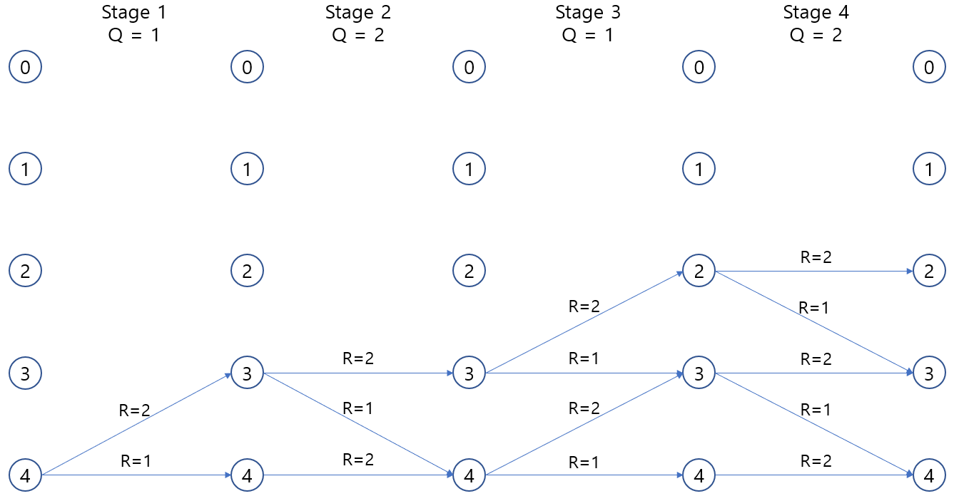

4.
B.
path = 'C:/Users/Lee/Desktop/2022년1학기/수자원시스템공학/HW2/'

################
f.release.rule = read.csv(paste0(path,'full_release_rule.csv'),header = T)
inflow = read.csv(paste0(path,'inflow.csv'),header = T)
colnames(inflow) = c('date','inflow')
demand = read.csv(paste0(path,'demand.csv'),header = T)
################
initial.storage = 40.025
Smax = 108.7
Smin = 6.2
flexible.demand = (3 * 3600 * 24) / 1000000
################
storage = array(NA, c(365))
storage[1] = inflow[1,2] - demand[1,2] + initial.storage

for (i in 2:365){
#i=282
release.rule = f.release.rule[i,2:5]
inflows = inflow[i,2]
demands = demand[i,2:4]
stor = storage[(i-1)]

if (stor > release.rule[1]){
dd = flexible.demand + sum(demands[2:3])
storage[i] = max(Smin, inflows + stor - dd)
}else if (release.rule[1] > stor & stor > release.rule[2]){
storage[i] = max(Smin, inflows + stor - sum(demands[1:3]))
}else if (release.rule[2] > stor & stor > release.rule[3]){
storage[i] = max(Smin, inflows + stor - sum(demands[1:2]))
}else if (release.rule[3] > stor & stor > release.rule[4]){
if (demand[i,1]==6){
storage[i] = max(Smin, inflows + stor - sum(demands[1]) - (0.8 * sum(demands[2])))
}else if (demand[i,1]==7 | demand[i,1]==8 | demand[i,1]==9){
storage[i] = max(Smin, inflows + stor - sum(demands[1]) - (0.7 * sum(demands[2])))
}else{
storage[i] = max(Smin, inflows + stor - sum(demands[1:2]))
}
}else{
storage[i] = max(Smin, inflows + stor - (0.8 * sum(demands[1:2])))
}
}

act.release = array(NA, c(365))
act.release[1] = sum(demand[1,2:4])
for (i in 2:365){
act.release[i] = storage[(i-1)] + inflow[i,2] - storage[i]
}

LHS = initial.storage + sum(inflow[,2])
RHS = storage[365] + sum(act.release)

write.csv(storage, file=paste0(path,'hedging_storage.csv'), row.names = F)

C.
LHS = 120.8349
RHS = 120.8695

D.
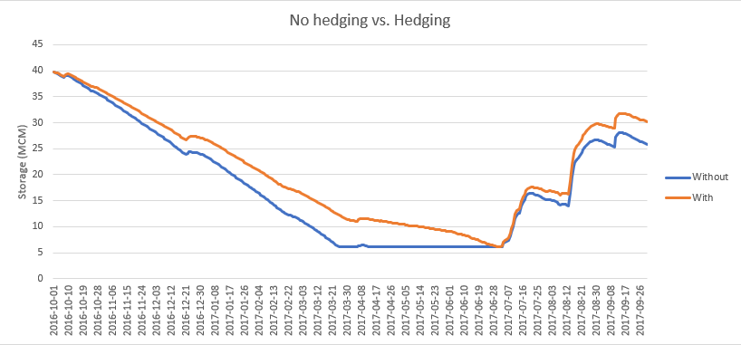
Because the effect of hedging rules, the duration of the minimum storage decreased. Moreover, considering hedging rule, the ability to recover from drought seems much better than when hedging rule is not considered.

